The Rotary Club of Sherborne Castles “ Youth Speaks” Competition
Rotary International has for many years run public speaking competitions for young people. Each year thousands of students take part in events that culminate in the Regional and National finals to which participants travel from all over the country. The competition aims to offer an experience of speaking on a public platform as members of a team. This year the local event was kindly hosted by Sherborne Preparatory School and held on November 26th. In all, nine teams aged between 11 and 13 entered the event. They represented Leweston school, Sherborne School for Girls,The Gryphon school, and the Preparatory school itself. Each team of three were asked to introduce their topic, speak for five minutes on a subject of their choice and after to give a vote of thanks. There were some very interesting presentations made debating….
- The idea that children should be given greater freedom to make their own choices
- That sport should be optional in schools
- The dilemmas involved in naming your child
- Dyslexia
- Dare2Dream
- Steiner Schools “hippy idylls or valuable educators”
The competition was judged by three adjudicators Mr William Heath, Mrs Isobel Allan and Mrs Sally Westlotorn who commented on the very high standard of all the presentations. They judged the overall winner to be a team from the Gryphon School. Their speaker Callum Morley very confidently and with great humour got the audience to consider his proposition “Don’t you just hate it when???” Adding to the overall success of his team were his President Curtis Pope and his Proposer Rory Baird. Judged in second place were a team from the Preparatory school who spoke about whether “Barbie is an Icon”. Their team members were speaker Thea Cottrell who was supported by Izzy Toovey and Oscar Leach. In third place were another team from the Preparatory school, Archie Macintosh, Emily Wastell and Genevieve Baker who talked “About good things in small packages”.
The first three teams will now progress on to the regional event to be held in February, with ambitions of progressing further. The national final will be held on Sunday 28th April at the University of Hull where the winner will receive the Rotary International Challenge Trophy. Hopefully one of our successful teams will progress to this level.
The entire event was a great opportunity and a wonderful demonstration of the skills of those taking part and Rotary was delighted to support and celebrate the expertise of young people.

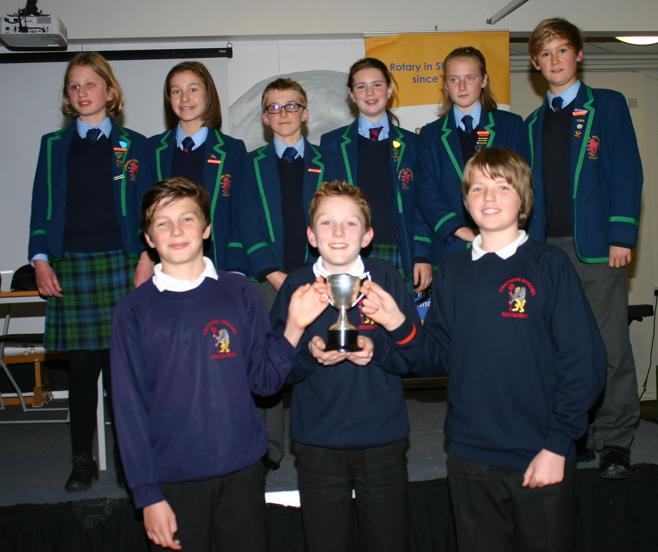
The proud winners from the Gryphon School showing off their trophy, with the second and third teams from Sherborne Prep.
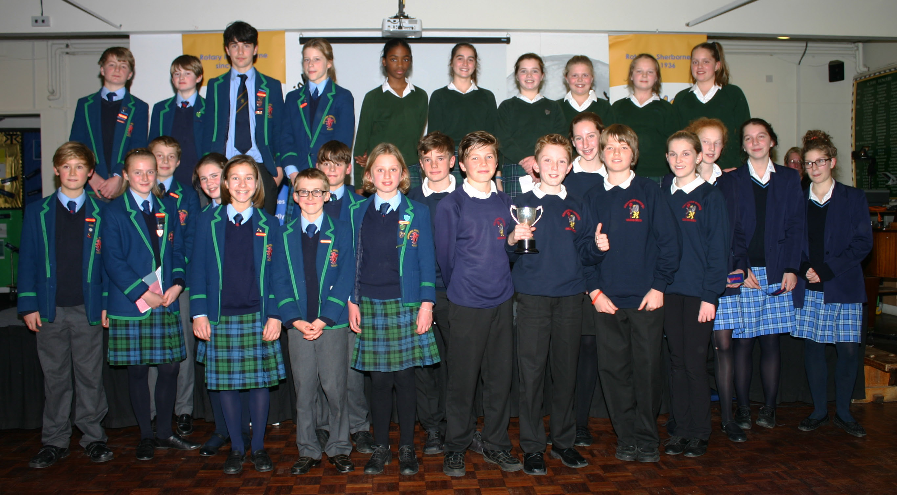
All the competitors were excellent and represented their schools admirably.

